
Solution Architecture

Date | 8 JULY 2026
Team ID | -
Project Name | AI Powered Debt Relief & Financial Recovery Platform
Maximum Marks | 5 Marks

Solution Architecture Diagram:
high-level visual representation of your solution's architecture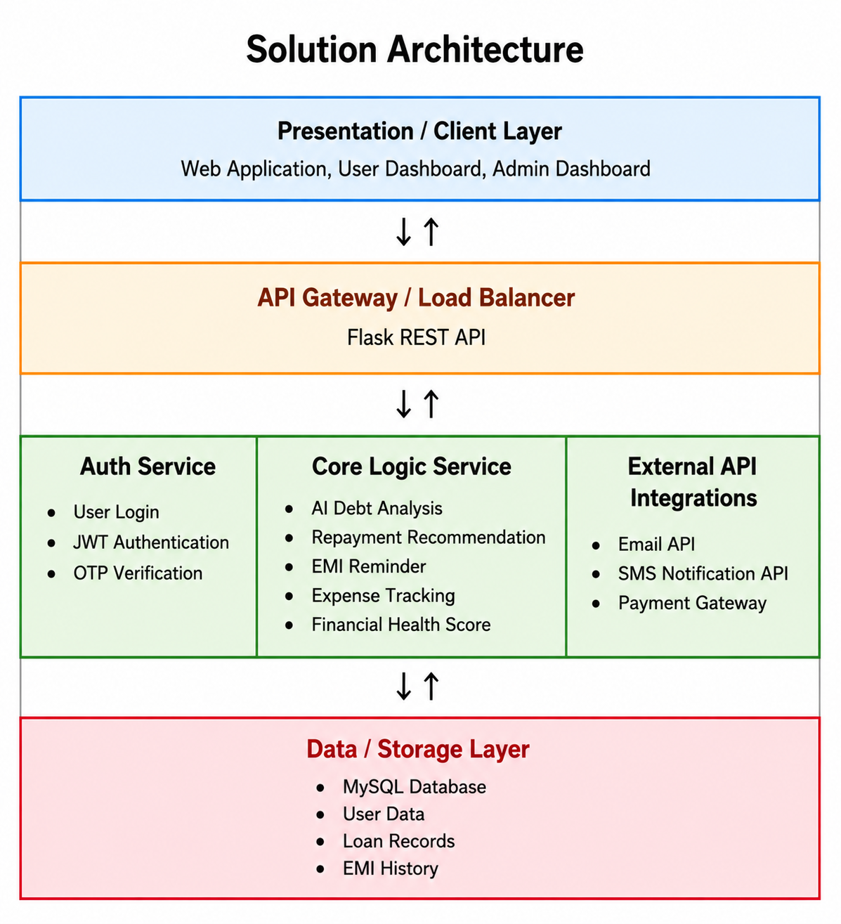


Component Description Table

Component Name | Description / Role in Architecture | Technologies Used
Presentation Layer | Provides user interface for borrowers and administrators. | HTML, CSS, JavaScript
API Gateway | Handles user requests and routes them to backend services. | Flask REST API
Microservices | Performs AI debt analysis, repayment recommendations, EMI reminders, and expense tracking. | Python, Scikit-learn, Pandas
Database | Stores user details, loan information, EMI records, and transaction history. | MySQL

